**GIT Workflow:**

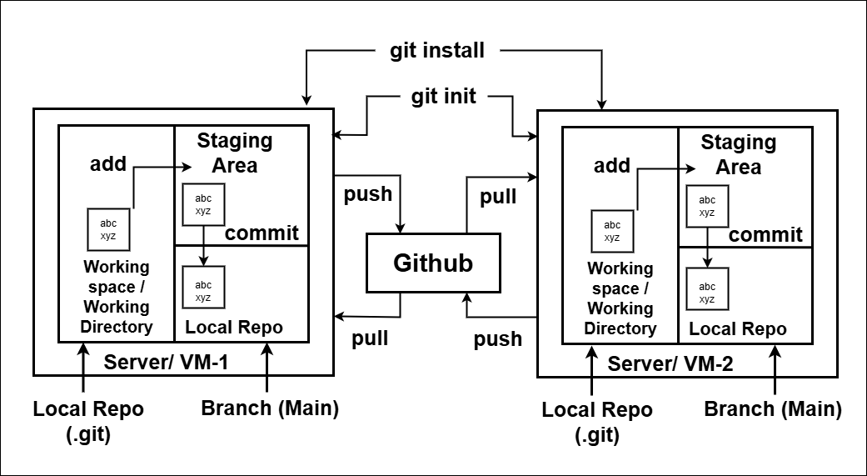

There are mainly three stages in git as follows:

1) Work Space/ Working Directory

2) Stagging Area

3) Local Repository

When we commit the code, then alternative snapshot created for that commit.

**Repository (storage):**

* It is a place where we have all over code, or kind of folder over server.
* It is a kind of folder related to our product. i.e. for new product, we need to create new repository.
* Changes are personal to that particular repository.

**Server:**

* It stores all repository. It may be local or remote server (central).
* It contains metadata also.

**Work Space/ Working Directory:**

* It is a place where we see files physically and do modification.
* At time we can work on a particular branch only.

**Staging Area:**

* After modification in the file, we add these files in staging area for committing it to the local repository.

**Commit:**

* It stores change in repository we will get one commit ID after committing the code.
* Commit ID contains 40 alphanumeric characters. We can use first 8 of them.
* It uses SHA-1 checksum concept.
* Even if we change one single dot, commit ID will get changed.
* It helps us to track the changes also.
* Commit also named as SHA-1 hash.

**Commit ID/version ID/ Version:**

* It is a reference to identify changes.
* It is used to track who changed the file.

**Tags:**

* Tags are assigned a meaningful name with a specific version in the repository.
* Once tag is created for particular save, even if we create a new commit, it will not be updated.

**Snapshot:**

* It represents some data of particular time.
* It is always incremental i.e. it stores the changes (appended data) only, not an entire copy.

**Appended = inserting new lines in existing code.**

**Branch:**

* Git branches are effectively a pointer to a snapshot of your changes.
* Each task has one separate branch.
* Product is same so one repository, but different tasks.
* Finally merges (code) all branch.
* It is useful when we want to work parallel on same product.
* We can create one branch on the basis of other branch and changes are personal to that particular branch.
* The default branch is Master or Main.
* File created in workspace will be visible in any of the branch workspace until we commit. Once we commit, then that file belongs to that particular branch.

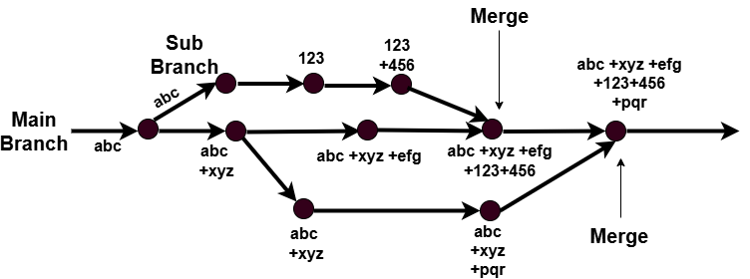

**Push:**

* Push operation copies change from local repository server poor remote or central depository.
* It is used to store permanently changes into GitHub repository.



**Pull:**

* Pull operation copies the changes from a remote repository to a local machine.
* It is used for synchronization between local repo and remote repo or between two repositories.

